Sales Rep Close Rate
Contents
The original assignment 1
Stakeholder 1
Methodology 1
Issues 2
Conclusion 3

The original assignment
To determine actual close rates by rep. Since reps are allowed to determine what is an opportunity and what isn’t, the concern is that they are inflating their close rates.
According to our project requirements, the close rate is calculated by sales closed by a salesperson divided by the opportunities received by that salesperson.
e.g. If John Doe received 18 opportunities in March and made 3 sales, then John Doe’s close rate in March is sales/opportunities, 3/18, or 16.67%

Stakeholder
Steve Short

Methodology
Use dwh_salesforce.MarketingSalesforceLeads to connect the answering rep in five9 to an opportunity. This allows us to associate an opportunity to a rep. This utilizes the foreign key, dwh_salesforce.MarketingSalesforceLeads.five9Id, which connects to dwh_five9db.calls.callid, and then retrieves the name of the agent who answered the call via dwh_five9db.agent.agentid on dwh_five9db.calls.agentid.
Use dwh_salesforce.MarketingSalesforceLeads to connect the opportunity to a dwh_reportsdb.subscription, which provides the closing rep’s name with dwh_reportsdb.subscription.soldBy. This connection uses dwh_salesforce.MarketingSalesforceLeads.pestRoutesSubscriptionId, which connects to dwh_reportsdb.subscription.subscriptionid. Since dwh_reportsdb.subscription.soldBy is a foreign key to dwh_reportsdb.employee.employeeid, the name of the agent who sold the subscription is found on dwh_reportsdb.employee.fullname.
The method may make more sense with sql code, which will be provided.

Issues
When the non-aggregated connection between these sources was made, a few issues were found using Excel to manually explore the data.
- In the following screenshot, we can see that the number of calls made by listed agents totaled 0 in March 2025 for each agent, which is unlikely. This data is found in the excel sheet Sales Close Rate XL - Monthly Answers, which will be provided with this write-up.
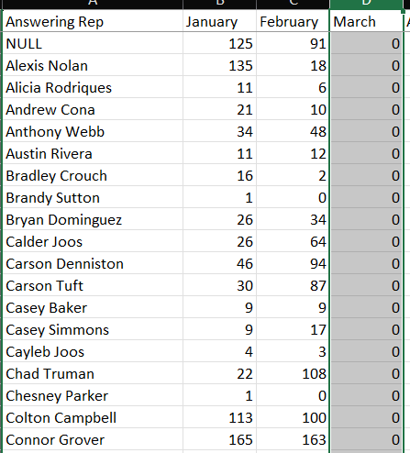
- It could not be determined whether the answering agents were salespeople or CSRs who happened to answer the phone
- There were many NULL values for the seller, as shown in the following screenshot. Furthermore, all reps were found not to have made any sales in March, also very unlikely
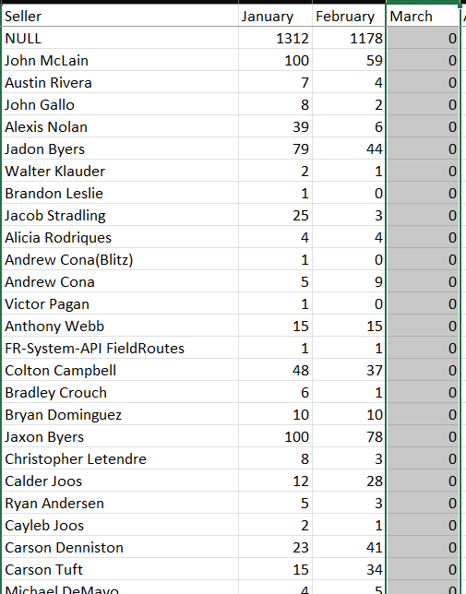

Conclusion
Overall, we feel we are missing important connections and data, especially considering that this close rate is applicable only to phone call leads.
Should we connect dwh_salesforce.MarketingSalesforceLeads.ownerid to dwh_reportsdb.employee.employeeid to determine which rep owns an opportunity? Do we then connect dwh_salesforce.MarketingSalesforceLeads.PestRoutesSubscriptionId to dwh_reportsdb.subscription.subscriptionId to determine the contract value of the sale and then connect dwh_reportsdb.subscription.soldBy to dwh_reportsdb.employee.employeeid to determine the name of the seller? If so, then is that an adequate connection to determine the sale/opportunity rates we’re looking for?

